
Database Design Report: Fast Food Ordering System
HIT 137 ASSESSMENT 3

neha (S394170)
Payal (S394005)
Monika (S395313)
Avni (S394331)

Table of Contents
1. Part A: Business Description and Rules 1
1.1. Business Situation: "Burger Haven" Ordering System 1
1.2. Business Rules 1
2. Part B: Map the ERD to EER Notation and Relations 3
3. Part C: Normalization 4
3.1. Flat Structure (Unnormalized Form - UNF) 4
3.2. Functional Dependencies 4
3.3. Relations in 3rd Normal Form (3NF) - Text Notation 4
4. References 5

Part A: Business Description and Rules

Business Situation: "Burger Haven" Ordering System
Burger Haven is an independent, medium-sized fast-food restaurant interested in replacing its current, manual and paper-based ticketing system with a digital database to handle its food ordering process. The proposed database will be used to track the customers, the employees who process the orders, the menu that is available and the specifics of every transaction.
The many-to-many relationship between orders and menu items may be a unique and potentially challenging element of this proposed application. Since one order may have multiple items, and a single item may be ordered in many different orders, the database must have an associative entity (Order Details) to accurately monitor the number of specific items in each order without causing a data redundancy (Coronel & Morris, 2018).

Business Rules
The following business rule and logical assumptions dictate the database design:
- Customer and Orders: A customer may have zero, one or multiple orders over time. Every order is ordered by only one customer.
- Employees and Orders: Each shift, an employee is allowed to process zero, one, or many orders. Only one employee processes each order.
- Orders and Menu Items: An order should have at least one menu item and can have many. The same menu item may be on none, one or numerous orders.
- Order Details: To resolve the many-to-many relationship between Orders and Menu Items, an entity called an Order Line or Order Detail will be used to record the exact quantity of each item ordered in a particular order.
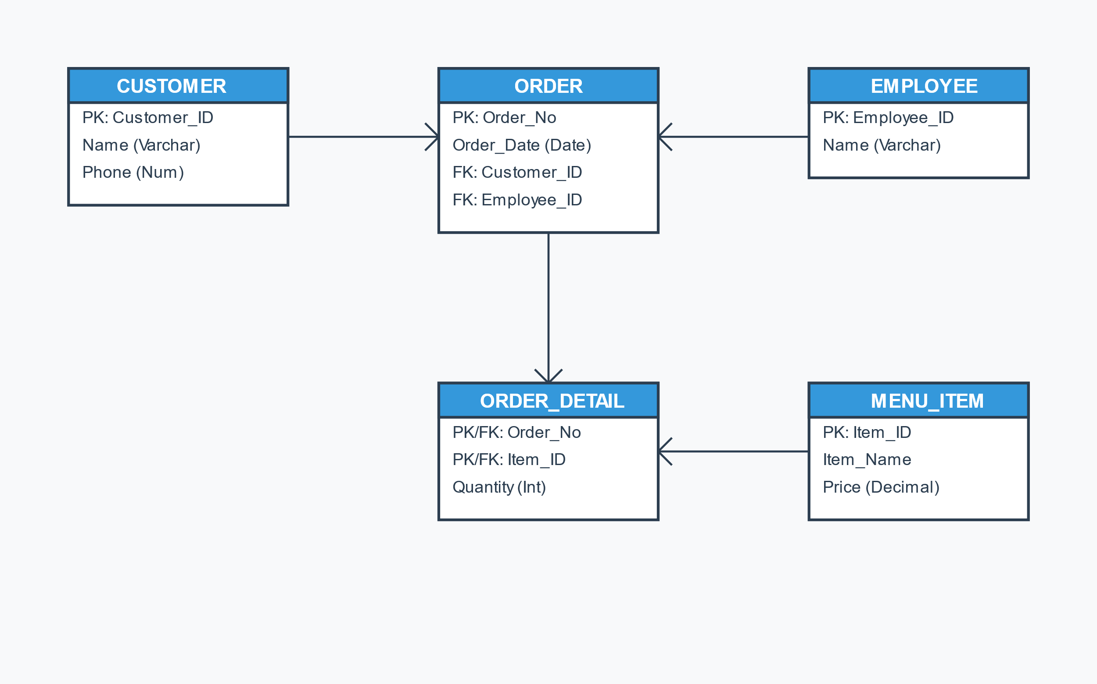
Figure 1.ER DIAGRAM

Part B: Map the ERD to EER Notation and Relations
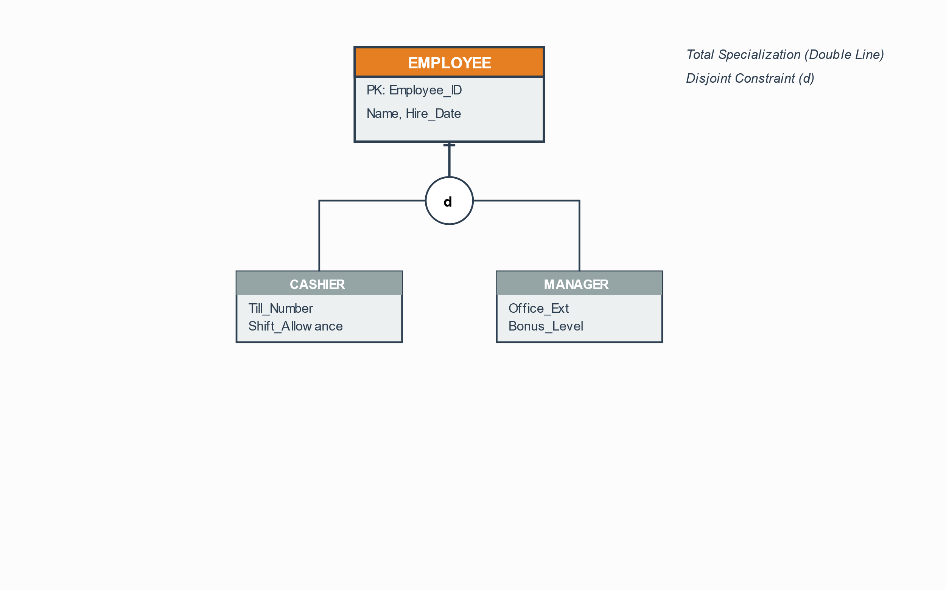
Figure 2. EER Diagram
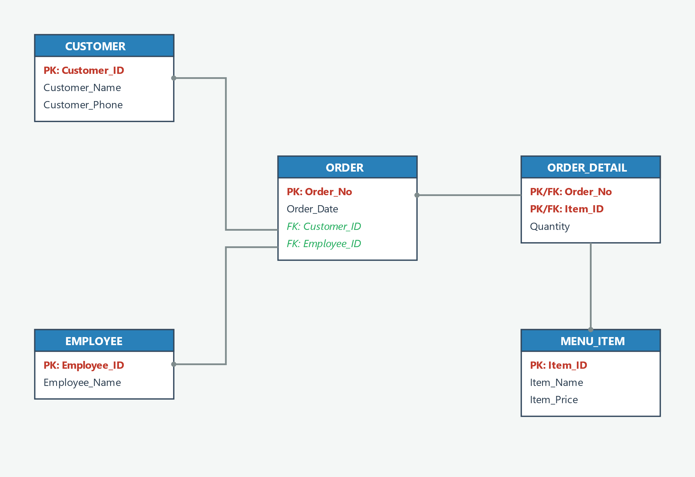
Figure 3.Relations Between Tables

Part C: Normalization
The database needs to be normalized to provide data integrity and eliminate anomalies such as insertion, update, and deletion of data (Elmasri and Navathe, 2015).

Flat Structure (Unnormalized Form - UNF)
This would be represented as having all the data attributes prior to normalization in a flat structure:
- UNF_ORDER (Order_No, Order_Date, Customer_ID, Customer_Name, Customer_Phone, Employee_ID, Employee_Name, {Item_ID, Item_Name, Item_Price, Quantity})

Functional Dependencies
Depending on the business rules, the following functional dependencies will exist:
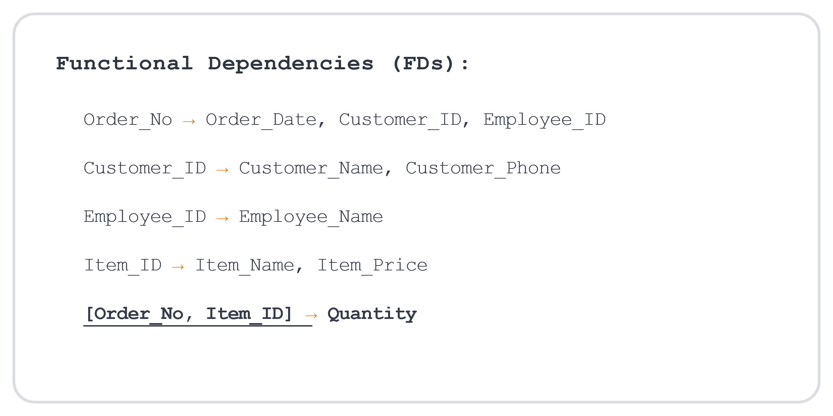

Relations in 3rd Normal Form (3NF) - Text Notation
The Final relational schema is created by eliminating repeating groups (1NF), partial dependencies (2NF), and transitive dependencies (3NF). The bold and underlined primary keys, and the italicized foreign keys..
- CUSTOMER (Customer_ID, Customer_Name, Customer_Phone)
- EMPLOYEE (Employee_ID, Employee_Name)
- MENU_ITEM (Item_ID, Item_Name, Item_Price)
- ORDER (Order_No, Order_Date, Customer_ID, Employee_ID)
- ORDER_DETAIL (Order_No, Item_ID, Quantity)

References
Coronel, C., & Morris, S. (2018). Database systems: Design, implementation, and management (13th ed.). Cengage Learning.
Elmasri, R., & Navathe, S. B. (2015). Fundamentals of database systems (7th ed.). Pearson.

